Fish Pathology Report
Lab use only:
Accession number:
Date received:
Cut in by:

DATE SUBMITTED:

SOURCE (NAME AND ADDRESS): TELEPHONE:
( )
COMMON NAME: |  | SCIENTIFIC NAME:
SOURCE CASE #: | SOURCE TANK I.D.: |  | AGE: | SEX: □ M □ F
ANIMAL USE:  □ Exhibit □ Quarantine  □ Research □ Breeding  □ Holding □ Other | SPECIMEN SUBMITTED:  □ Live animal □ Preserved tissue  □ Dead animal □ Gross only  Fixative: |  | MANNER OF DEATH:  □ Natural  □ Euthan. agent:
PRESERVED TISSUES SUBMITTED (CHECK): □ all tissues present

□ skin □ brain □ mouth □ spleen □ thyroid
□ muscle □ eye(s) □ esophagus □ pancreas □ gonad
□ bone □ nares □ stomach □ head kidney □ uterus
□ cartilage □ lateral line □ intestine □ caudal kidney □ epigonal
□ fin(s) □ swim bladder □ liver □ interrenal
□ other:
□ other:

HISTORY AND CLINICAL SUMMARY:
- Problems first noticed?

- Symptoms? Eating? Behavior?

- Treatments?

- Water quality?

- Biopsy results?

- Supporting studies (please attach results):
□ Parasitology □ Microbiology □ Hematology □ Viro-serology □ Other:
Notes:
Necropsy Work Sheet | Prosector:  Slides (#):
General examination: Weight (g): Length (mm):
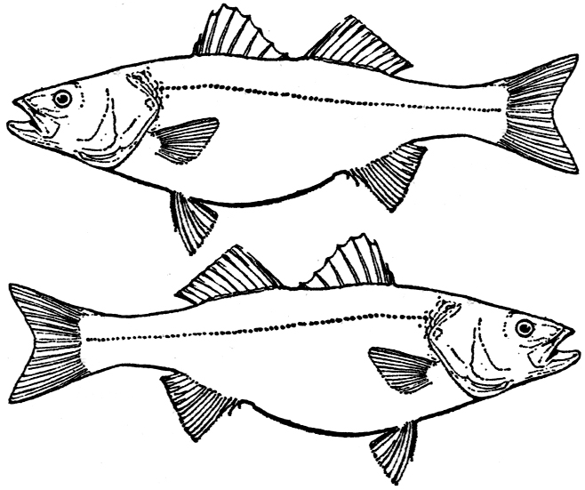
(physical condition, fins, orifices, skin, operculum)

Wet mounts:

Skin scrape:

Body cavity: Scrape/smear:
(peritoneum, mesenteries, etc.)
Respiratory system: Gill biopsy:
(gills pseudobranch)
Central nervous system and Sensory organs: Impression smear:
(meninges, brain, spinal chord, eyes, nares, lateral line)
Circulatory system: Impression smear:
(pericardial sac, heart, valves, great vessels) Hematocrit (%):
Total plasma solids mg/dl:

Gastrointestinal system: Gut scrape:
(mouth, esophagus, stomach, small & large intestine, rectum)
Liver and gall bladder: Impression smear:

Spleen & Pancreas: Impression smear:

Urinary system: Impression smear:
(anterior & posterior kidney, ureters)

Reproductive system: Impression smear:
(external genitalia, gonads, uterus, accessory organs)

Swimbladder: Int/ext. scrape:

Musculo-skeletal system: Scrape/smear:
(bones, muscle, cartilage; Bouin’s fixative for hard structures?)

Endocrine system: Impression smear:
(thyroid, interrenal, pituitary)

